AIPPM Matrix

BHARTIYA JANATA PARTY 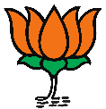

|  |
| --- |
| **Name** |
| Amit Shah |
| Anurag Singh Thakur |
| B S Yediyurappa |
| D V Sadananda Gowda |
| Dr Harsh Vardhan |
| Dr Mahendra Nath Pandey |
| Gajendra Singh Shekhawat |
| Gautam Gambhir |
| General (Retd) V K Singh |
| Giriraj Singh |
| Kiren Rijiju |
| Manoj Tiwari |
| Meenakshi Lekhi |
| Mukhtar Abbas Naqvi |
| Narendra Modi |
| Narendra Singh Tomar |
| Nirmala Sitharaman |
| Nitin Gadkari |
| Piyush Goyal |
| Prakash Javadekar |
| Rajnath Singh |
| Rao Inderjit Singh |
| Ravi Shankar Prasad |
| Sambit Patra |
| Santosh Gangwar |
| Yogi Adityanath |
| Smriti Irani |
| Subrahmanyam Jaishankar |
| Sunny Deol |
| Thaawar Chand Gehlot |

Indian National Congress 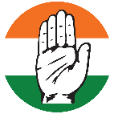

|  |
| --- |
| Adhir Ranjan Chowdhury |
| Ashok Gehlot |
| Dr Shashi Tharoor |
| Gaurav Gogoi |
| Gurjeet Singh Aujla |
| Kamal Nath |
| Amrinder Singh |
| Manish Tewari |
| Rahul Gandhi |
| Sonia Gandhi |
| Priyanka Gandhi |
| Jyotiraditya Scindia |
| Mohammad Sadique |
| Dr Mohammad Jawed |

DRAVIDA MUNNETRA KAZHAGAM 

|  |
| --- |
| Kanimozhi Karunanidhi |
| Dayanidhi Maran |

ALL INDIA TRINAMOOL CONGRESS 

|  |
| --- |
| Abhishek Banerjee |
| Mamata Banerjee |
| Mahua Moitra |

YSR CONGRESS PARTY 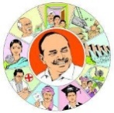

|  |
| --- |
| Anuradha Chinta |
| Midhun Reddy |
| JaganMohan Reddy |

Shiv Sena 

|  |
| --- |
| Uddhav hackerey |
| Rajan Baburao Vichare |
| Arvind Sawant |

JANATA DAL (UNITED) 

|  |
| --- |
| Kaushalendra Kumar |
| Nitish Kumar |

BIJU JANATA DAL 

|  |
| --- |
| Bhartruhari Mahtab |
| Pinaki Misra |
| Naveen Patnaik |

BAHUJAN SAMAJ PARTY 

|  |
| --- |
| Kumari Mayawati |
| Shyam Yadav Singh |

TELANGANA RASHTRA SAMITHI 

|  |
| --- |
| Kotha Prabhakar Reddy |
| Nama Nageswara Rao |

LOK JAN SHAKTI PARTY 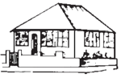

|  |
| --- |
| Chirag Paswan |
| Ram Vilas Paswan |

NATIONALIST CONGRESS PARTY 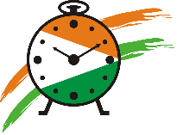

|  |
| --- |
| Supriya Sule |
| Faizal PP Mohammed |

SAMAJWADI PARTY 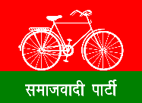

|  |
| --- |
| Mohammad Azam Khan |
| Akhilesh Yadav |
| Mulayam Singh Yadav |

COMMUNIST PARTY OF INDIA (MARXIST) 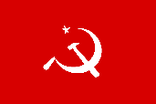

|  |
| --- |
| P R Natarajan |
| Sitaram Yechury |

JAMMU & KASHMIR NATIONAL CONFERENCE 

|  |
| --- |
| Dr Farooq Abdullah |
| Omar Abdullah |

ALL INDIA MAJLIS-E-ITTEHADUL MUSLIMEEN 

|  |
| --- |
| Asaduddin Owaisi |

COMMUNIST PARTY OF INDIA 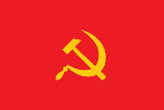

|  |
| --- |
| M Selvaraj |

SHIROMANI AKALII DAL 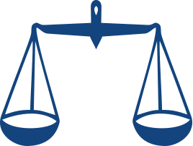

|  |
| --- |
| Harsimrat Kaur Badal |
| Sukhbir Singh Badal |

AAM AADMI PARTY 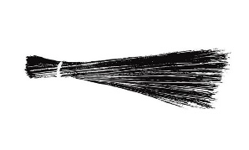

|  |
| --- |
| Bhagwant Mann |
| Arvind Kejriwal |
| Manish Sisodia |